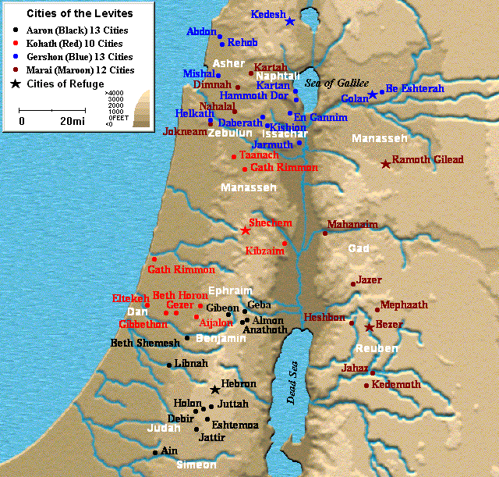
Conquest of Canaan
Map of Cities given to Levites

